**Binary Search Tree Projesi**

**[7, 5, 1, 8, 3, 6, 0, 9, 4, 2]**

**Root**

**Key Edge**

Subtree

Parent

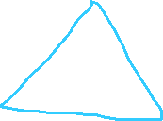

**Siblings**

Child